|  |  |
| --- | --- |
| Affine transformations in the Euclidean plane  Affine transformations  In Chapter 1 we discussed the two fundamental aspects of geometry: the incidence aspect based on the notion of collinearity, and the metric aspect based on the notion of distance. Isometries are the transformations that respect these features.  In this chapter we want to enlarge our world of transformations to include those that respect incidence but do not necessarily preserve distance. There are two reasons for doing this. First, we want to be able to recognize and classify figures according to their shapes rather than insisting on the stronger condition of congruence. For example, we want to have transformations that relate similar triangles. The second reason is computational convenience. The algebraic conditions that determine an isometry are more difficult to work with than those based merely on incidence.  Definition. A collineation is a bijection T: E2 E2 satisfying the condition that for all triples P, Q, and R of distinct points, P, Q, and R are collinear if and only if TP, TQ, and TR are collinear.  Although this definition, like the original definition of isometry, is appealing because of its geometric flavor, it does not lend itself immediately to computation. We need a more algebraic version.  Definition. A mapping T: E2 E2 is called an affine transformation if there is an invertible 2 by 2 matrix A and a vector b e R2 such that, for all  2  Tx = Ax + b. | 2 |
| Remark: By Theorem 1.38 every isometry is an affine transformation. | 39 |

Remark: The matrix A and the vector b mentioned in the definition are uniquely determined by T. In fact, b = T(O) and the columns of A are the vectors TEi = 1, 2. We call A the linear part of T, and b the translation part of T.

Theorem 1. Every affine transformation is a collineation.

Proof: The following identity, which can be easily checked, directly shows that affine transformations are surjective.



On the other hand, if Ax + b = Ai + b, then A(x — i) = 0. Because A is invertible, we must have x = i. Thus, affine transformations are injective.

Finally, for any points P and Q and any affine transformation T, it is easy to check that

+ tQ) = (1 - DTP + tTQ (2.1)

for all real t. Thus, if R is a point collinear with P and Q, TR will be collinear with TP and TQ. Conversely, if R' is a point collinear with TP and TQ, there is (because T is surjective) a unique point R with TR = R' But now we know that

TR = (1 - DTP + tTQ (2.2)

for some number t. Because T is injective, (2.1) and (2.2) yield



and R is collinear with P and Q.

Corollary. Every isometry is a collineation.

Theorem 2. Every collineation is an affine transformation.

The proof of Theorem 2 is too technical to present here but is included in Appendix E. From now on in this chapter we will treat the word "collineation" as a synonym for affine transformation.

# Fixed lines

If T is an affine transformation and e is a line, then TC is a line. We now show how to compute this line in terms of the data determining T and e.

Theorem 3. Let T be an affine transformation, and let = P + [v] be a line. 40 Then TC is the line TP + [Av], where A is the linear part of T.

Proof: Let b be the translation part of T. For real t, Fixed lines

+ tv) = + tv) + b = TP + tAv.

From this equation we can see that every point of TC lies on TP + [Av], and conversely. Note that TC is in fact a line because Av * O.

Corollary. Let T be an affine transformation with linear part A and translation part b. A line P + [v] is a fixed line of T if and only if v is an eigenvector of A and (A — I)P + b e [v]. (The notion of eigenvector is discussed in Appendix D.)

Theorem 4.

1. If two fixed lines of an affine transformation intersect, they do so in a fixed point.
2. If two fixed lines of an affine transformation are parallel, every line in the pencil containing these lines is fixed.
3. If two lines are parallel, their images under any affine transformation are parallel.

The reader may prove these facts as an exercise. (See Exercise 2.)

We now have the machinery required to prove Theorem 40 of Chapter 1:

Proof (of Theorem 1.40): Let e = P + [v] be a line, and let T be an affine transformation with linear part A and translation part b.

CASE 1: T is a nontrivial translation, so A = I and b * 0. Then v is automatically an eigenvector of A, and C is a fixed line if and only if b e [v]. Thus, the fixed lines of T are those with direction [b].

CASE 2: If Tis a half-turn about a point C, then from Exercise 1.26, A = —I and b = 2C. Again, v is automatically an eigenvector, and C is a fixed line if and only if —2P + 2C e [v]; that is, C e P + [v]. Thus the fixed lines of T are those that pass through C.

Now consider the case of a rotation having A = rot 0 * ±I. Then A has no nonzero eigenvectors (Exercise 1.31); therefore, T can have no fixed lines.

CASE 3: T is a reflection with axis m. Clearly, m is a fixed line.

Furthermore, if m — Q + [w], where IWI = 1, then for all real t,

+ twi) = Q + twi — 2<twi, wi)wi = Q — tw-L

Thus, Q + [w i l is a fixed line. In other words, 0m leaves fixed all lines perpendicular to m. By Theorem 4(i), any fixed line not perpendicular to m must meet the pencil of perpendiculars to m in fixed points. Because 0m has no fixed points except on m (Theorem 1.21), o m can have no additional fixed lines. 41

CASE 4: T = C)mTkw is a glide reflection consisting of reflection in a line m with unit direction vector w and a translation by a nonzero multiple of w.

We first show that m is a fixed line. Let Q be any point of m. Then for real t,



Thus, the line m is a fixed line.

Because T has no fixed points, any other fixed line would have to be parallel to m. Let C = Q + sw i + [w] be a typical line parallel to m. Then

+ swi + m,) = 0m (Q + swi + (t + k)w)

+ (t + k) w — 2 < sw-L + (t + w -L

Note that C cannot be fixed unless s = O.

# The amne group AF(2)

We now look at the result of successively applying two affine transformations. If

Tx = Ax + b and rx = Ax + b, then

= A(ÄX + b) + b = (AÄ)X + Ab + b.

Thus, the composition of two affine transformations is again an affine transformation. One can arrange that Tr = I by choosing Ä = A -l and b = —A —1 b, thus showing that the inverse of an affine transformation is also an affine transformation. To summarize, we have proved

Theorem 5. The set AF(2) of all affine transformations of R2 is a group, called the affine group of R2

Elements of AF(2) may be conveniently represented by matrices as follows: Write

## a ll a 12

and b — a21 a22

If y = Ax + b, we may easily check that the 3 by 3 matrix equation

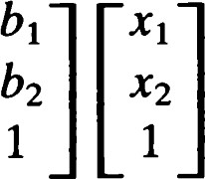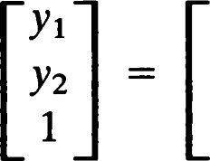all an am an(2.3) O O

holds and that the composition operation in AF(2) corresponds to matrix Fundamental theorem of multiplication of the associated 3 by 3 matrices. affine geometry

If GL(3) denotes the group of all invertible 3 by 3 matrices, then AF(2) is a subgroup of GL(3). This representation may be abbreviated as

where the sizes of the various matrices are understood from the context. These ideas are formalized in Exercise 6.

# Fundamental theorem of amne geometry

Affine geometry consists of those facts about E2 that depend only on incidence properties and not on perpendicularity or distance. Although affine geometry is interesting in its own right, we will be concentrating here on those aspects that will help us to solve problems of congruence and symmetry of figures.

The fundamental theorem gives a clear and simple criterion for existence and uniqueness of affine transformations, namely, that any two triangles can be related by a unique affine transformation.

At this point it is useful to highlight a fact that arose in the proof of Theorem 1 — affine transformations preserve order along lines.

Theorem 6. Let P and Q be points, and let T be an affine transformation. Then

1. For any real number t,

- + tQ) = (1 - t)TP + tTQ. (2.1)

1. A point X lies between P and Q if and only if TX lies between TP and TQ. Furthermore,

d(P, X) d(TP, TX)

d(P, Q) = d(TP, TQ)'

We are now in a position to derive an important uniqueness property of affine transformations.

Theorem 7.

1. If an affine transformation leaves fixed two distinct points, then it leaves fixed every point on the line joining these points.
2. If an affine transformation leaves fixed three noncollinearpoints, it must be the identity. 43

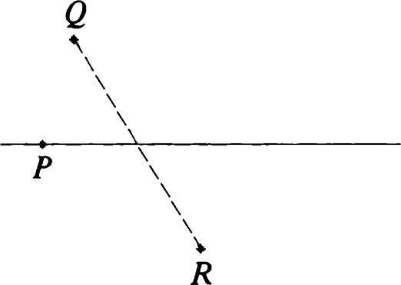

Figure 2.1 The affine reflection

[P; Q RI.

Proof: The first claim is immediate from formula (2.1). Now, let P, Q, and R be three noncollinear points that are left fixed by an affine transformation T. Let X be any point not lying on any of the lines PQ, QR, or RP. Let A be the midpoint of the segment PQ. Now XA cannot be parallel to both QR and RP; hence, it meets one of these lines in a point B (distinct from A). Because X is on a line containing two fixed points A and B, X itself must be a fixed point. We conclude that T leaves every point in the plane fixed and therefore is the identity.

Our proof of Theorem 7(ii) is a synthetic proof. It uses geometric ideas derived earlier and geometric arguments.

In following the proof it is helpful to make your own diagram. An alternative proof using linear algebra is suggested in Exercise 7.

We now come to the fundamental theorem, which asserts the existence of a unique affine transformation relating any two triangles.

Theorem 8. Given two noncollinear triples of points, PQR and P' Q' R' there is a unique affine transformation Tsuch that TP = P', TQ = Q', and



Proof: Because {Q — P, R — P} and {Q' — P', R' — P'} are bases for E2 (Appendix D), there is an invertible 2 by 2 matrix A such that A(Q — P) =

Q' - P' and - P) = R' - P'. Let T = Tp,AT-p. Then TP =

- P) = P'. Similarly, TQ = Q' and TR = R'. Thus, we have constructed an affine transformation with the required property.

We now show that there is only one such transformation. Suppose that r agrees with T on P, Q, and R. Then r —I T is an affine transformation that leaves P, Q, and R fixed. By Theorem 7, r -I T= I; that is, T = r.

## Affine Reflections

Let P, Q, and R be noncollinear points of E2 . The unique affine transformation (guaranteed to exist by the fundamental theorem) that leaves P fixed while interchanging Q and R is called an affine reflection and is denoted by the symbol (used in [81).



(see Figure 2.1). Clearly, every ordinary reflection is an affine reflection. In fact, let e be any line, P any point on e, Q any point not on C, and R — OeQ. Then it is easy to verify (Exercise 8) that

 (2.4)

|  |  |
| --- | --- |
| We shall soon see that not every affine reflection is an isometry. However, affine reflections share some of the properties of ordinary reflections. To begin with, an affine reflection T must be involutive because T2 has three noncollinear fixed points. In addition, we have  Theorem 9. Let M be the midpoint of a segment QR, and let P be any point not collinear with Q and R. Then the affine reflection [P; Q RI leaves fixed every point of PM but no other points.  Proof: We first check that M is a fixed point. To see this, write  Tx = Ax + b as usual. Then  Q = TR = AR + b and R = TQ = AQ + b.  Hence, | Affine reflections |



|  |  |
| --- | --- |
| that is,  M = AM + b = TM,  and M is a fixed point. By Theorem 7(i), PM consists entirely of fixed points. On the other hand, the affine reflection is not the identity, so it cannot have any additional fixed points, by Theorem 7(ii).  Theorem 10. The affine reflection [P; Q RI leaves fixed the line PM and all lines parallel to QR and no other lines. (Notation is as for Theorem 9.)  Proof: Because TQ and TR determine the same line as Q and R, we see that the line e = QR is fixed. Each line C' parallel to e meets PM in a fixed point M'. Thus, TC' passes through M' while remaining parallel to TC = e (Theorems 4(iii) and 1.17). This guarantees that TC' = C'; that is, e ' is a fixed line. Finally, suppose that C" were a fixed line not parallel to e but distinct from PM. Then C" meets C' and e in fixed points. This contradicts the fact that all fixed points are on PM.  Theorem 11. The affine reflection [P; Q RI is an isometry if and only if PM QR.  Proof: Suppose that the given affine reflection is an isometry. Because it has a line of fixed points, it must be an ordinary reflection with axis PM, by Theorem 1.39. But QR is a fixed line of this reflection, and thus it must be perpendicular to PM by Theorem 1.40. | 45 |

Conversely, suppose that PM -L QR. Let m = PM. We show that 0m interchanges Q and R and thus, by the fundamental theorem, must coincide with the given affine reflection. To this end, note that

omQ = Q - - M, N)N,

where N is.a unit vector in the direction [Q — R]. But



Thus,



Also = OmOmQ = Q. Hence, 0M interchanges Q and R.

Q R

# Shears

The fundamental theorem of affine geometry can be used to define other classes of affine transformations. Let P, Q, and R be noncollinear points. The unique affine transformation that leaves fixed every point on the line through P parallel to QR and that takes Q to R is denoted by [P; Q -4 RI and is called a shear. See Figure 2.2.

Theorem 12. The shear [P; Q * R] has the line through P parallel to QR as its set of fixed points. The fixed lines are those belonging to the pencil of parallels determined by QR.

Proof: Let T be the shear in question. T can have no fixed points other than those on the line m = P + [Q — RI. Otherwise, it would be the identity.

Let e = Q + [Q — R]. Because e Il m and Tm = m, TC is the unique line through R = TQ parallel to m. In other words, TC = C, and e is a fixed line.

Finally, let X be any point lying neither on e nor on m, and let X' = TX. The line XX' must be parallel to m; otherwise XX' would have to meet m in a fixed point B and XB = X' B would be a fixed line. But now the fixed lines QR and XB would have to intersect in a fixed point, which is impossible. This shows that TX lies on X + [Q — R] and, hence, that X + [Q — R] is a fixed line. Our argument also shows that no other lines of E2 can be fixed.

Remark: The line of fixed points of a shear is called its axis.

Theorem 13. A shear whose fixed points lie along the -El-axis has a matrix of the form

1 o 1 (2.5) o 1

Proof: Because the origin is a fixed point, the translation part is O. Also, the vector €1 is a fixed point, and this determines the first column of the matrix. Finally, the shear must take to a point on the horizontal line €2 + [El]. This determines the form of the second column.

Remark:

1. Every matrix of the form SR, X * O, determines a shear.
2. If T is a shear with axis e, and p is any affine transformation, then pTp -l is a shear with axis PC.

These facts follow easily from the fundamental theorem (Exercise 9). A shear whose axis is a horizontal line through a point P can be written

P + sx(x - P), (2.6)

and a shear whose axis passes through the origin and has direction vector (cos 0, sin 0) = (rot O)EI can be written

Tx = (rot (—0))x, so that any shear with axis P + [(rot e)E11 can be written in the form

Tx = P + (rot (—0))(x — P) (2.7)

for some real number X * O.

## Dilatations

A dilatation is an affine transformation with the property that for each line e, either TC = e or TC Il e. The identity is said to be a trivial dilatation.

Theorem 14. A dilatation that leaves two points fixed must be the identity.

Proof: Suppose that P and Q are distinct fixed points of a dilatation T. Then every point on the line PQ is fixed. Let X be any point not on PQ. Then T takes the line PX to a line through P with the same direction. In other words, PX is a fixed line. By the same argument QX is a fixed line, and so X is a fixed point. Because T has three noncollinear fixed points, it must be the identity.

Thus, a nontrivial dilatation can have at most one fixed point. A dilatation with exactly one fixed point is called a central dilatation, and the fixed point is called its center. See Figures 2.3 and 2.4.

## Dilatations

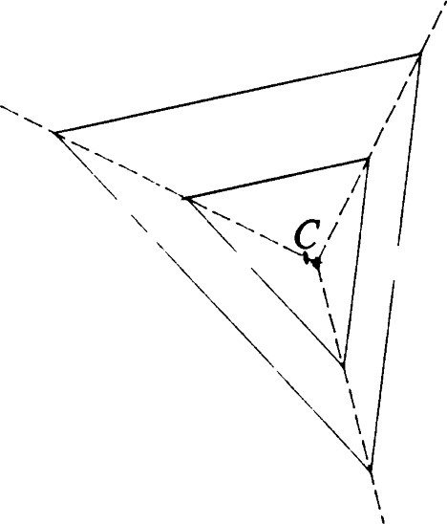

Figure 2.3 Two triangles related by a central dilatation.

Figure 2.4 Two more triangles related by a central dilatation.

Theorem 15.

i. A central dilatation with center C may be written in the form

(2.8)

The number IKI is called the magnification factor of T. ii. A dilatation that has no fixed points is a translation.

Proof: Let T be a central dilatation with center C. Because T is a

dilatation, every vector v e R2 must be an eigenvector of A (the linear part of T). Thus, there is a nonzero real number K such that A = KI (Exercise 10).

Because TC = C, the translation part of Tis equal to C — KC, so that for all x E2 ,



This proves (i). Further, if K * 1, the equation + b = x has a solution x = 1/(K — l))b. Hence, every dilatation is either a translation (K = 1) or has a fixed point.

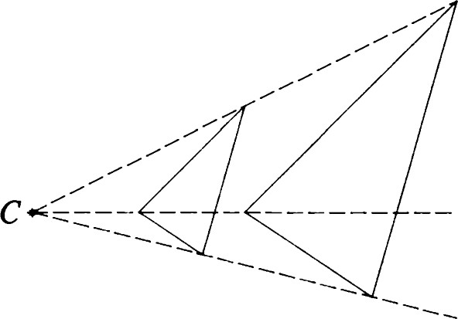Theorem 16. The fixed lines of a central dilatation are precisely those that pass through its center.

Proof: First, note that



so that all lines through C are fixed. On the other hand, if any fixed line C does not pass through C, pick an arbitrary point X on this line. Then CX and e are fixed lines intersecting in X. Because X cannot be a fixed point, we have a contradiction.

Remark: A half-turn is a special central dilatation having K

# Similarities

Definition. A mapping T: E2 -+ E2 is called a similarity (with magnification factor K > O) if, for all X, Y e E2 ,

d(TX, TY) = Kd(X, Y).

A similarity can be accomplished in two stages: first, a central dilatation (to make objects the right size); then an isometry (to move objects to the right position).

Theorem 17. Every similarity is a central dilatation followed by an Affine symmetries isometry. In particular, every similarity is an affine transformation.

Proof: Let T be a similarity with magnification factor K. Let S be the central dilatation defined by

1

sx = —x.

Then

d(TSX, TSY) = Kd(SX, SY)

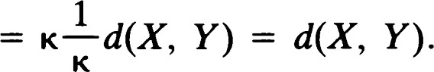

Thus, TS is an isometry, and, hence, T is this same isometry preceded by the central dilatation S I

Theorem 18.

1. If Tl and T2 are similarities with respective magnification factors Kl and then TIT2 is a similarity with magnification factor KIK2.
2. If T is a similarity with magnification factor K, then T —l is a similarity with magnification factor 11K.

Proof: Exercise 11.

Corollary. The set of similarities of E2 is a group, which we denote by Sim(E2).

Definition. Two figures ef and 92 are similar if there is a similarity T such that = 92 •

# Affine symmetries

Let F be any figure. An affine transformation leaving fixed is called an affine symmetry of 9, and the set of all affine symmetries is a group called the affine symmetry group of F. We use the notation MY(F) = {T  f}.

Because every isometry is an affine transformation, we have

90(9) C ug(f) C AF(2).

In the next section we will set up a framework for classifying the affine symmetries of a wide class of figures. In the meantime we will examine the symmetries of some very simple figures.

Theorem 19. Let F be the set consisting of a single point. Then (F) — GL(2), the group of 2 by 2 invertible real matrices.

Proof: Let P be the point. If Te Mg then T-pTTp leaves O fixed, and its translation part is 0. We write T-pTTp = A, where A is linear, and conclude that T = TpAT-p; that is, Tx = P + A(x — P)for all x e E2 . It is now a routine matter to check that the mapping that takes T to A is an isomorphism (Exercise 12).

Theorem 20. Let be a set consisting of two points. Then dg(F) is isomorphic to the group of 2 by 2 matrices of the form

|  |  |  |
| --- | --- | --- |
| Writing | with p * 0.  and T- | (2.9) |
| one can verify that the interesting subsets are | form a subgroup of MS' | Some other |

i. the subgroup 90 (F) determined by = 0, p = ± 1, ii. the subgroup {Th+,plp = 1} consisting of all shears leaving the two given points fixed together with the identity, iii. the set {Tk+,plp = —1} of affine reflections leaving the two points fixed, iv. the subgroup — 0, p > O} consisting of stretches in the direction of the xyaxis, including the identity as a special case.

Remark: After we have studied projective geometry (Chapter 5), we will be able to see that these transformations are merely the affine versions of the projective collineations leaving a line pointwise fixed. In projective geometry these break down into two types: homologies and elations.

## Rays and angles

Let P be a point of E2 , and let v be a nonzero vector. Then

z = {P + tvlt 0} (2.10)

is called a ray with origin P and direction vector v. Clearly, every line through P is the union of two rays with origin P. Their direction vectors are negatives of each other.

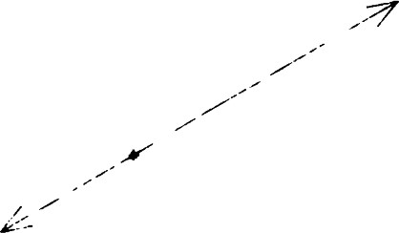The union of two rays El and with common origin P is called an angle with vertex P and arms and 02. We allow the possibility = h, in which Rays and angles case we refer to the angle as a zero angle. If and are two halves of the same line, we say that they are opposite rays and that the angle is a straight angle. Finally, if -L we call the angle a right angle. (Two rays are perpendicular if their direction vectors are orthogonal.)

Given two distinct points P and Q, there is a unique ray with origin P that passes through Q. We denote this ray by PQ. The angle with vertex Q and arms QP and QR is denoted by &PQR or, equivalently, &RQP. Rays

and angles may be represented as shown in Figures 2.5—2.8. Figure 2.5 A straight angle.

It is now time to define a numerical measure for angles. This must be done in terms of analytic concepts, taking care not to appeal to our pictorial notions of angle measurement.

Definition. Let be an angle whose arms have unit direction vectors u and v. The radian measure of is defined to be Figure 2.6 A zero angle.

## cos -l (u, v (2.11)

Remark: If we write u = (cos 0, sin 0) and v = (cos 4, sin +), then the radian measure a is the unique number in [O, T] such that

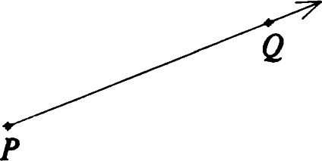 (rot = v or (rot = u.

In other words, there is a rotation by a taking one arm of to the other.

(See Exercise 14.)

Figure 2.7 The ray PQ.

Theorem 21. Let be any angle. Its radian measure a is

i. 0 if and only if d is a zero angle, ii. IT if and only if is a straight angle, iii. between O and otherwise.

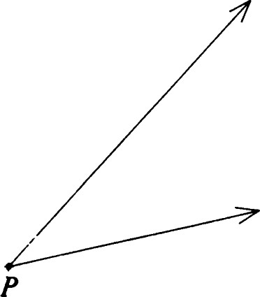Furthermore, a = IT/2 if and only if is a right angle.

Definition. An angle d is acute if its radian measure is <T/2. It is obtuse if its radian measure is >1T/2. See Figures 2.9—2.11.

Theorem 22. Let = &PQR be an angle. Then

1. 4 PQR is acute if and only if (P — Q, R — Q) is positive.
2. 4 PQR is obtuse if and only if (P — Q, R — Q) is negative.

Figure 2.8 An angle with vertex P.

Definition. Let be an angle with vertex P and radian measure a. Let u and v be unit direction vectors of its arms chosen so that (rot a)u = v. Then a ray with origin P and direction vector rot(a/2)u is called a bisector of

Remark: A straight angle has two bisectors. Any other angle has a unique bisector.

Theorem 23. For any angle there is a unique reflection that interchanges its arms, namely, the reflection in the line containing the bisector(s) of d.

|  |  |
| --- | --- |
| e + | |
|  |  |

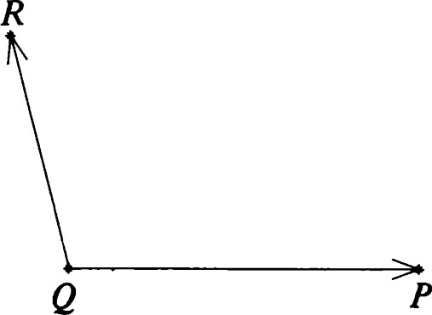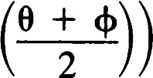Proof: Let u, v, and a be as in the previous definition. If P is the vertex of d, set T = +  where u = (cos 0, sin 0) and v = (cos (b, sin Then

## T(P + tu) = p + ( ref (

 t ref (rot O)EI Figure 2.9 An obtuse angle.

 t(rot (b)



for all real t. Thus, Tai = and, by symmetry, T22

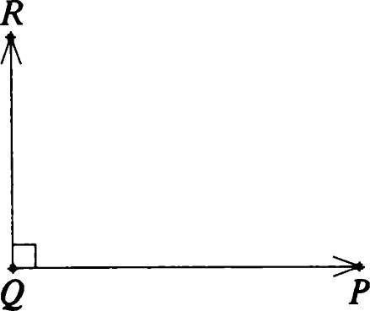To show uniqueness, let r be any other reflection that interchanges and 22. Then rT leaves the rays 21 and fixed. Hence, their point of intersection P is fixed. Because TP = P, we have that rp = P. Thus, the axis of the reflection r passes through P, and rTis a rotation about P. Now the only rotation that leaves a ray fixed is the identity (Exercise 21), and we conclude that rT must be the identity. Thus T = r.

Figure 2.10 A right angle.

# Rectilinear figures

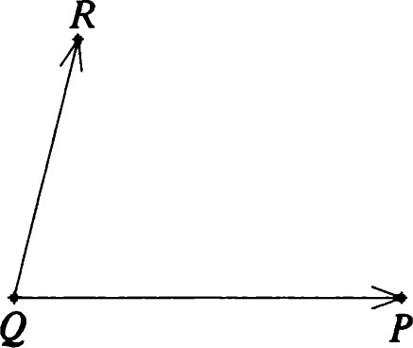A union of finitely many segments, rays, and lines is called a rectilinear figure. Familiar examples are triangles, squares, and angles. We will study these in detail later. First, we develop some techniques for computing symmetry groups that are applicable to all rectilinear figures.

Let be any rectilinear figure. The figure 5 consisting of all lines that Contain lines, segments, or rays of Fis called the rectilinear completion of

f. A rectilinear figure is said to be complete if, whenever a segment is in 9, the line containing it is in F. Then 5 is clearly the smallest complete rectilinear figure containing F. See Figures 2.12 and 2.13.

Figure 2.11 An acute angle.

Theorem 24. Let T be an affine transformation, and let be a rectilinear figure. Then T maps the set of lines of bijectively to the set of lines of T F.

Proof: We first show that the map is surjective. Suppose that TC is a line of T F, but e is not in 5. Then for each line of 5, Tm meets TC in at most one point. Because T F n TC is contained in the union of all the Tm, it can contain only finitely many points. But this is impossible because TC contains at least a segment of T F and, hence, an infinite number of points of TF.

It only remains to show that if is any line of F, then Tm is a line of T F. First note that m contains a segment that is contained in F. Then Tmo is a segment in T". Thus, T F contains the line determined by Tmo, namely, Tm.

Corollary. Suppose Tis an affine symmetry of a rectilinear figure F. Then T permutes the lines of its rectilinear completion 9.

Definition. Suppose that is a rectilinear figure. A point of where two lines of F intersect is called a vertex of F.

Theorem 25. Let F be a rectilinear figure and T an affine transformation. Then T maps the set of vertices of bijectively to the set of vertices of TF.

If T is an affine symmetry of F, then T permutes the vertices of F.

Proof: We need only show that T maps vertices of to vertices of TF. The rest is trivial.

Let P be a vertex of 9. Then TP is a point of TF. Because P is the intersection of two lines of 5, TP is the intersection of their images, which, by Theorem 24, are in T F. Thus, TP is a vertex of TF.

Corollary.

1. Every affine symmetry T of a rectilinear figure ef is also an affine symmetry of 5.
2. Every affine symmetry of a rectilinear figure F permutes the set of vertices of eÉ that are not vertices of F.

## Rectilinear figures

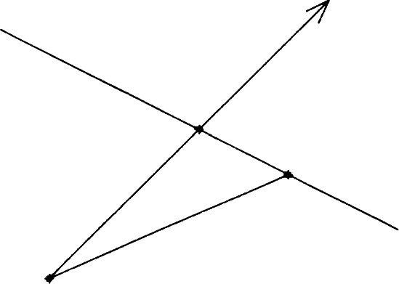

Figure 2.12 A rectilinear figure.

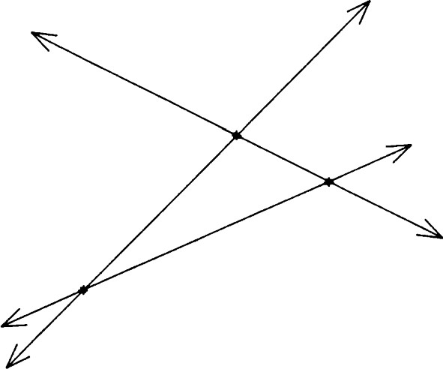

Figure 2.13 Completion of the proof: rectilinear figure in Figure 2.12.

1. Because T permutes the lines of and 5 is the union of these lines, we must have T 5 = 5.
2. Because T is an affine symmetry of 5, T must permute the set of vertices of 5. But T being an affine symmetry of F must permute the vertices of F among themselves (i.e., this set is invariant under the permutation). Hence, T must permute the remaining vertices of among themselves.

Corollary. If is a rectilinear figure having at least three noncollinear vertices, then dSO(F) is a finite group.

Proof: Denote the three noncollinear vertices by P, Q, and R. Then each permutation of the vertices of can be realized by at most one affine transformation. The only possible candidate is the unique affine transformation (guaranteed by the fundamental theorem) that agrees with the given permutation on P, Q, and R. In general, of course, this candidate

may fail to agree with the permutation on some other vertex. Even if it accomplishes the permutation of the vertices, it may fail to be a symmetry of F. In any case, the affine symmetry group has at most n! elements, where n is the number of vertices.

Remark: If all the vertices of a rectilinear figure are collinear, then MY(F) is still a finite group, but the preceding proof will not work. Complete figures of this form can be described explicitly, and we shall explore these in Chapter 3, Exercise 7.

# The centroid

Let F be a finite set of points of E2 . For x e E2 define

 (2.12)

PEF

Theorem 26. There is a unique point ofE2 where the function f achieves its minimum value. This point is called the centroid of F.

Proof: Let n be the number of points of F. Then f(x) = (x - P, x - P)

— 2K x, p) + Ip12)

nlx 2 - 2<x, EP) + Elp1 2 .

Write C = (1/n)EP and b = (1/n)ElP1 2 .

Then

f(x) = n(Ix12 - 2<x, C) + b)

— n(lx1 2 — 2K x, C) + IC12 + b - lcf) = nlx — C1 2 + n(b — IC1 2).

Clearly,f(x) is minimum precisely when x = C.

Remark: If F is a rectilinear figure with a finite number of vertices, the centroid of the set of vertices is often referred to as the centroid of F.

Theorem 27. Suppose that is a rectilinear figure having a finite nonzero number of vertices. Let C be the centroid of F. Then, for any isometry T, TC is the centroid of TF.

Proof: First, note that P is a vertex of if and only if TP is a vertex of

54 T". Also, the quantity

## E Ix - TP1 2 = - TP1 2 = - PF Symmetries of a segment

has its minimum value when T-lx is the centroid C of F; that is, x = TC. Thus, TCis the centroid of TF.

Corollary. If Tis a symmetry of a rectilinear figure f with a finite number of vertices, then T leaves the centroid of fixed.

# Symmetries of a segment

Let PQ be a segment. We compute its symmetry group SO (PQ). First of all, we know that any affine transformation T takes the segment PQ to a segment P'Q', where P' = TP and Q' = TQ. We first show that T permutes the set {P, Q}•

Lemma. A segment determines its end points; that is, if PQ and PO denote the same segment, then {P, Q} = {P, Q}.

Proof: Interchanging P and if necessary, we may write

P = (1 - + and O = (1 - + SQ, where O < t < s < 1. Now, there exist i and S in [O, 1] such that

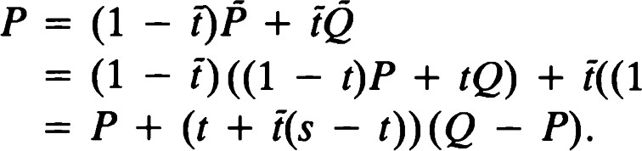 - + SQ)

Because Q * P, we must have t + i(s — t) = 0. But the conditions t O, i > 0, s — t > O imply that t = 0 and i(s — t) = O; that is, i = O. This proves that P = P. The proof that Q = Q is similar.

There are two isometries that leave {P, Q} pointwise fixed: the reflection Oe with axis C = PQ, and the identity. On the other hand, there are exactly two isometries that interchange P and Q. Clearly, one is the reflection 0m whose axis is the perpendicular bisector of PQ. But if T is any other isometry interchanging P and Q, the composition 0m T leaves P and Q fixed. This gives

O MT = 1 and T = 0m, or

## O MT = oe and T = oeo„ = HM,

where M is the midpoint of PQ. Thus, SP (PQ) consists of four elements: two reflections, a half-turn, and the identity. The multiplication table for this group is

|  |  |
| --- | --- |
|  |  |
|  | HM  HM |

The abstract group having this multiplication table is called the Klein four-group.

We state the results we have outlined as a theorem. You will be asked to fill in the details of the proof in Exercise 23.

Theorem 28. The symmetry group of a segment has four elements: two reflections, a half-turn, and the identity. The group multiplication table is as indicated beforehand.

# Symmetries of an angle

Let be an angle other than a straight angle. In this section we compute the symmetry group g

We first prove a uniqueness lemma.

Lemma. Let be an angle with vertex P. Suppose that an affine symmetry Tof leaves both lines of fixed. Then T leaves both arms of dfixed.

Proof: Let and be the lines and and the associated rays. Let v and w be unit direction vectors of and 42, respectively. Write Tx = Ax + b. Because TP = P, we get AP + b = P, so that we may write



Because is a fixed line, [Av] = [v] (Theorem 3). Thus, there is a real number such that Av = Xv. Now T(P + v) = Av + P = P + Xv. Because T maps into M, P + Xv must be in d. Hence, is positive, and TCI = 21.

Similarly, Ti2 =

Corollary. In the lemma if T is an isometry, then T is the identity.

Proof: The string of equalities

IVI = + v, P) = + v), TP) = + NV, P) = - 

yields Av = v. By symmetry, Aw = w, and, hence, A is the identity matrix.

56 Finally, for all x,

 Symmetries of an angle so that Tis the identity.

Remark: If is a straight angle, then (as a set of points) is just a line. If  is a zero angle, then is a ray.

Theorem 29. Suppose that Tis an affine symmetry of an angle d. Then T permutes the arms of d.

Remark: In case is a zero angle, we interpret this to mean that T leaves the one arm of fixed.

Proof: Let and be the arms. Let and be the lines containing and 02, respectively. Let be the line that contains the bisector of d. By the corollary to Theorem 23, T permutes the lines and G. If TCI — and 'TG = 82, then the lemma implies that T leaves fixed and 02. If TCI — and TG = 81, then 0m T leaves fixed and and, hence, and h. But then

02 and

= = 21.



=

Corollary. g(d) consists of two elements 0M and I.

Proof: If T e g then either T leaves and fixed and is therefore the identity, or T leaves and fixed and is therefore the identity. In the latter case, T =

Remark: This also shows that if a is any ray, then g (a) consists of two elements: reflection in the line of u, and the identity.

The following will be useful when we discuss triangles.

Theorem 30. Let 4 PQR be an angle. Suppose d(P, Q) = d(Q, R). Let be the line containing the bisector of 4PQR. Then interchanges P and R while leaving Q fixed.

Proof: Write P — Q = IP — Qu and R — Q = IR — Qlv, and use the notation of Theorem 23. It is sufficient to check that C)MP = R.

C)MP = TQ ref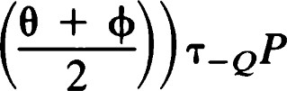

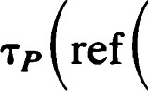0

2--9) IP - QIu

QIv = Q + IR — QIv

+ R - Q = R.

# Barycentric coordinates

Let P, Q, and R be noncollinear points. For each point X e E2 there is a unique triple (X, p, v) of real numbers such that

 (2.13)

and + p, + v = 1. The association

V is called a barycentric coordinate system, and PQR is called the triangle of reference. (See Exercise 25.)

Remark:

1. This generalizes the fact that points on a line PQ may be uniquely written as XP + pQ, where X + p = 1.
2. We will see that the values of the barycentric coordinates X, p, and v relate in a nice way to the position of X with respect to the triangle of reference.
3. Barycentric coordinates have a physical interpretation. If weights of k, p, and v are placed at P, Q, and R, respectively, the center of mass of the resulting configuration will be at X. This also applies, of course, to the case of a line, as described in (i).

Theorem 31. Let PQ be a line, and let R be any point not on PQ. Using PQR as a triangle of reference, we have, for any point X with barycentric coordinates k, p, v,

i. v = O if and only if X lies on PQ. ii. v > O if and only ifXR n PQ = Ø.

Proof: If v = 0, this means that

X = XP + B.LQ = (1 - + pQ, (2.14)

and, hence, X lies on PQ. Conversely, if X lies on PQ, then (2.14) holds for some value of p, and by uniqueness of the representation in (2.13), we

58 must have v = 0.

If v > (), then, for 0 < t < 1,

(1 - + (1 - t)xp + (1 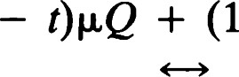 - t)vR + tR.

Because (1 — t)v + t > 0, XR cannot intersect PQ. On the other hand, if v < 0, there is a value of t satisfying (1 — + t = O; that is,



# 1 - V

Note that O < -v/(l - v) < 1. Thus, PQ n XR * Ø.

Definitlon. Let e be a line, and let R be a point not on e. The half-plane determined by e and R is the set of X such thatXR n e = Ø. See Figure 2.14.

Theorem 32.

1. Every line e determines two half-planes. The reflection Oe interchanges the half-planes.
2. Let e be a line, and let P and Q be arbitrary points on C. Let R be any point not on e. Then the half-plane determined by e and R is the set of points having v > 0. (Again the triangle of reference is PQR.) The set of points having v < O is the half-plane determined by e and OCR. The two half-planes are said to be opposites of each other.

Remark: When two points are in the same half-plane, we say that they are on the same side of e. Points in opposite half-planes are said to be on opposite sides of e.

Definition. A point X is said to be in the interior of an angle 4 PQR if X > 0

## Barycentric coordinates

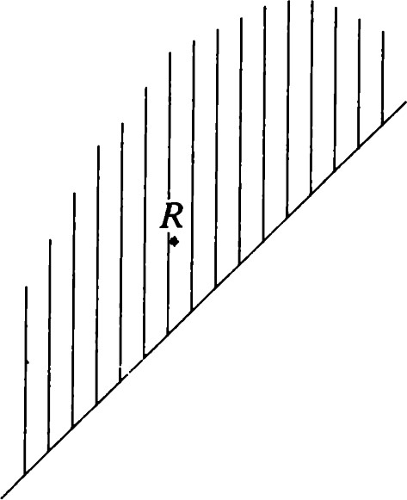2

|  |
| --- |
| and v > 0. See Figure 2.15. Figure 2.15 The interior of an angle.  Remark: This is the same as saying that X and R are on the same side of PQ while X and P are on the same side of QR.  Theorem 33 (The crossbar theorem). Let X be a point in the interior of the angle 4PQR. Then the ray QX intersects the segment PR. (See Figure  2.16.)  Proof: Using PQR as triangle of reference, we obtain  Q + (X - Q) = (1 - + + tpQ + tvR  = tXP + (1 — t -F tp)Q + tvR. Figure 2.16 The crossbar theorem.  We need to choose a positive value of t so that 1  = 0; that is,  -1 1 |

Figure 2.14 A half-plane consisting of all points X such that XR n e = Ø.

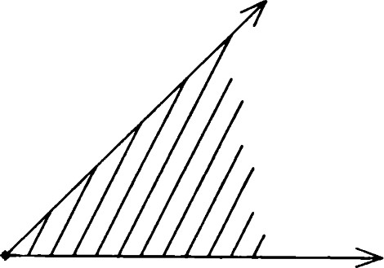

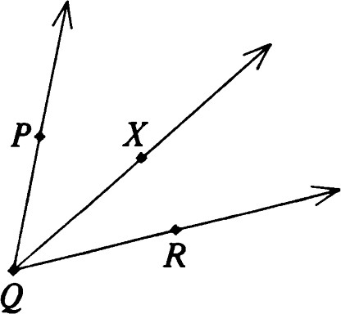

Figure 2.17 Addition of 4PQX and 4XQR to form 4PQR.

## 60

Because 1 — B.L = + v > O, this value of tis indeed positive. Furthermore,

— p) > O and Vt = v/(l — p) > 0, so that Q + t(X — Q) lies on PR.

### Addition of angles

Theorem 34.

i. Let 4 PQR be an angle and X a point in its interior. Then the radian measure of 4 PQR is the sum of the radian measures of 4 PQX and 4RQX. (See Figure 2.17.) ii. Let 4 PQR be a straight angle and X any point not on the line PQ. Then the sum of the radian measures of 4 PQX and 4 RQX is equal to IT.

Remark: In (ii), 4 PQX and 4RQX are said to be supplements of each other. We speak of the pair as a pair of supplementary angles.

Proof: (i) Let 0, 01, and 02 be the respective radian measures. There is no loss of generality in assuming that u = P — Q, v = R — Q, and w = X — Q are unit vectors and that (rot = v. Because X is in the interior of 4PQR, we may write

### X- Q = - Q) + I.L(R - Q);

that is,



where X and p are positive. According to the definition of radian measure, there are four possibilities:

1. (rot 01)u = w and (rot 02)w = v. Then (rot (01 + = v and 01 + 02 0 (mod 21'"). But 0 < 01 + 02 < 21T, so that, in fact, 01 + 02 = 0, as required.

The other three possibilities cannot occur. We examine them in turn.

1. (rot 01)u = w and (rot 02)v = w. Then

0 < sin 01 = (u i , W) = p<u l , v

and

O < sin 02(VI , W) = X(vl , u

But (u l , v1 so we have a contradiction.

1. (rot 01)w = u and (rot 02)w = v. This is similar to case (2). We get the same expressions for the negative numbers sin (—01) and sin (—02) and, thus, a contradiction.

|  |  |  |
| --- | --- | --- |
| 4. | (rot 01)w = u and (rot 02)v = w. In this case, O < sin 02 i) as in (2).  But | Triangles |

o < sin e —

a contradiction.

For part (ii) with 4 PQR a straight angle, we have no expression for w in terms of u and v. But v = —u and v-L = —u l . This makes the proof easier. For (1), e = IT and 01 + 02 = IT by the same argument. For (2),

O < sin 01 = , ) = sin 02 < O,

a contradiction. Case (3) is similar. Case (4) can occur and gives

 + 02 = IT

as in (1).

### Triangles

Let P, Q, and R be noncollinear points of E2 . The triangle PQR (sometimes written APQR) is the rectilinear figure consisting of the segments PQ, QR, and PR, These segments are called the sides of the triangle.

Theorem 35. Let PQR be a triangle. Using PQR as the triangle of reference for a barycentric coordinate system, we have that

1. 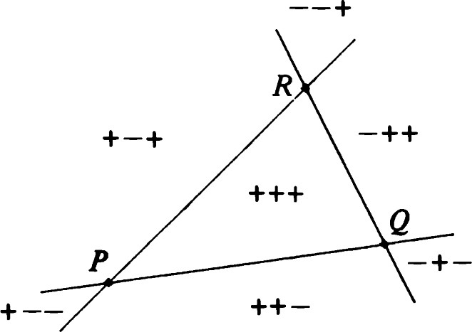A point X e E2 is a vertex of APQR if and only if exactly two barycentric coordinates are zero.
2. A point X is on the figure APQR if it is a vertex or if one barycentric coordinate is zero and the others are positive.

Definition. A point is in the interior of APQR if it is in the interior of all three angles determined by P, Q, and R.

Remark: Points in the interior of the triangle are characterized by having.

|  |  |
| --- | --- |
| all three barycentric coordinates positive. Figure 2.18 shows the whole plane divided into seven regions characterized by the signs of the barycentric coordinates X, p, v. For example, the interior of the triangle is characterized by the combination +++.  Theorem 36. An affine transformation T takes a triangle APQR to the triangle AP'Q'R', where P' = TP, Q' = TQ, and R' = TR. | Figure 2.18 Regions of the plane as characterized by the signs of the barycentric coordinates.  61 |

Proof: APQR is the union of three segments belonging to three distinct lines. According to Theorem 6, these segments are transformed by T to the respective segments making up AP'Q'R'. The fact that P', Q', and R' are noncollinear and thus form a triangle relies on knowing that E l is an affine transformation and thus preserves collinearity (Theorems 1 and 6).

### Symmetries of a triangle

Let A be a triangle. If T is an affine symmetry of A, then T permutes the vertices of A. Conversely, by the fundamental theorem, every permutation of the vertices is realized by a unique affine transformation. Thus JSP(A) is the group of six elements known as the symmetric group S3. Algebraically, we may describe the group as {I, a, a2 , ß, aß, a2ß}, where ßa = a2ß and a3 = I. In terms of permutations we can set

 = (PQR), (PQ).

Clearly, ß is the affine reflection [R; P  Q]. Note also that the product of the two affine reflections



corresponds to the permutation (PQR) — a. Here is the multiplication table for the group S3:

|  |  |  |  |  |  |  |
| --- | --- | --- | --- | --- | --- | --- |
|  |  |  | 2 | ß | aß | a2ß |
| 2  ß aß a2ß | 2  ß  a2ß | 2  a2ß ß aß | 2  1    a2ß | ß  a2ß  2 | aß a2ß ß  2 | a2ß  aß    2 |

We now investigate g (A). Clearly, g(A) is a subgroup of Mg

Definition. A triangle is

i. scalene if all three sides have different lengths; ii. isosceles if exactly two sides have equal lengths; iii. equilateral if all three sides have the same length.

Theorem 37. g(A) consists of

62 i. The identity only if A is scalene.

1. {I, O} if A is isosceles with d(P, Q) = d(P, R). O is thi affine reflection [P; Q R]. Of course, O is an actual reflection (isometry) in this case.
2. All elements ofUSP(A) if A is equilateral. In this case, two elements are nontrivial rotations about the centroid, three are reflections (one in each median), and the sixth is the identity. (A median is a line that passes through a vertex and the midpoint of the opposite side.)

Proof: Because we already know the affine symmetries, it is only necessary to check which of these are isometries. If T = [P; Q e R] is an isometry, we must have d(P, Q) = d(TP, TQ) = d(P, R), so that at least two sides of A must be of equal length. The same holds for the other two affine reflections.

If T is an isometry that permutes the vertices cyclically, then

d(P, Q) = d(TP, TQ) = d(Q, R), say, = d(TQ, TR) = d(R, P),

so that A must be equilateral.

Thus, when A is scalene, only the identity can be an isometry. If A is isosceles, then [P; Q e R] is an isometry (Theorem 11 and Exercise 8). Finally, if A is equilateral, all three affine reflections are isometries. The cyclic permutations, being products of reflections, are ordinary rotations.

Corollary. Let A be an equilateral triangle with centroid C. Then g(A) consists of

i. the identity, ii. the three reflections in the medians of A, iii. rotations by ±2T/3 about C.

Proof: First note that

## C = + Q + R) = -F + 12 R). (2.15)

Similarly,



and



This exhibits C as a point on all three medians. Thus, the product of two reflections in g(A) is a rotation about C. In fact, if we write

T = TM(rot o)T-M,

then

 TM(rot and T3 = TM(rot

Symmetries of a triangle

63

Now T3 = lif and only if rot 0 = rot (±2T/3).

We have also deduced the following well-known property of the centroid.

Corollary. For any triangle the centroid lies on each median and divides it in the ratio of 2:1.

### Congruence of angles

Theorem 38. Two angles are congruent if and only if they have the same radian measure.

Proof: Let and g be congruent angles, and let T be an isometry such that TM = g. By Theorem 24, T maps the two lines of to the two lines of and, hence, the vertex of to the vertex of g. Let u and v be unit direction vectors for the arms of d. If A is the linear part of T, the arms of g must have Au and Av as direction vectors. Because A is orthogonal, that is, (Au, Av) (u, v), the two angles have the same radian measure.

Conversely, suppose that angles and g have the same radian measure. We may assume that (rot = v and (rot O)u' = v', where the arms of (respectively, 4) have unit direction vectors u, v (respectively, u', v'). Let be a number such that

u' = (cos + (sin= (rot 4)u.

Then

#### v' = (rot O)u' = (rot(e +

= (rot  = (rot 4)v.

Let P and Q be the respective vertices of U and g. Then fort 0,

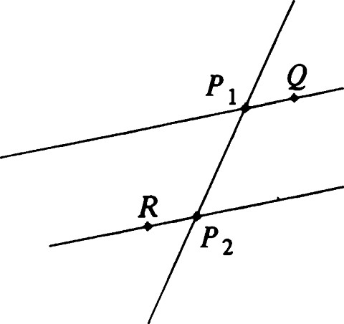 TQ(rot + tu ) = TQ(rot 4)tu

= TQ(tU') = Q + (tu')

Similarly,

TQ(rot + tv) = Q + tv' .

Thus, and g are congruent.

Figure 2.19 A transversal determines A line that intersects two lines in distinct points is called a transversal to two pairs of alternate angles.  these lines. Let and be parallel lines with direction vector v. Suppose that is a transversal meeting and in PI and P2, respectively. Let Q = PI + v and R = P2 - v. Then 4P2PlQ and are called alternate angles. Note that a transversal determines two pairs of alternate

64 angles. (See Figure 2.19.)

Theorem 39. When a transversal meets two parallel lines, the pairs of alternate angles they determine are congruent.

Proof: Use the notation introduced in the paragraph preceding Theorem 39. Note that Hp,Tp2-pI takes PIQ to P2R and PIP2 to P2Pl.

Remark: The isometry Hp'h—p, is in fact a half-turn about the midpoint of PIP2.

### Congruence theorems for triangles

We now prove the well-known congruence theorems of Euclidean geometry. The first one (sometimes referred to as the SSS theorem) says that two triangles whose vertices can be matched in such a way that corresponding sides have equal length must be congruent.

Theorem 40. Let APQR and AP'Q'R' be such that d(P, Q) = d(P', Q'), d(P, R) = d(P', R'), and d(Q, R) = d(Q', R'). see Figure 2.20. Then there is an isometry T such that TP = P', TQ = Q', and TR = R'

Proof: Our method of proof is like that of Euclid, making use of isometries to carry out the "superposition" on which the ancient proof relies. The proof is divided into four steps.

1. Given two lines 81, G, there is an isometry Tsuch that TCI = (i.e., J(E2) is transitive on the lines of E2 ). To see this, note that if 81 1182, reflection in the line lying halfway between them will interchange and 82. On the other hand, if intersects G, a reflection in any of the bisectors of the angles they form will interchange and 82.
2. If PQ and P 'Q' are collinear segments of equal length, there is an isometry Tsuch that TP = P' and TQ = Q t . This can be done by Tp,-p or (Exercise 32).
3. Suppose that d(P, R) = d(P, R') and d(Q, R) = d(Q, R'). Then there is an isometry leaving e = PQ pointwise fixed and taking R to R'. In fact, I or Oe will do (Exercise 33).
4. Choose an isometry Tl taking PQ to P' Q'. Then choose T2 to take TIP to P' and TIQ to Q'. Let T3 map T2TlR to R' while leaving P'Q' pointwise fixed. Then T = T3T2T1 accomplishes the desired effect. 

Another famous assertion of Euclid proves congruence based on lengths of two sides and the angle they determine (the SAS theorem). In order to prove this, we first derive the so-called Law of Cosines. Lemma. Let P, Q, and R be three points of E2 . Then

#### Congruence theorems for triangles

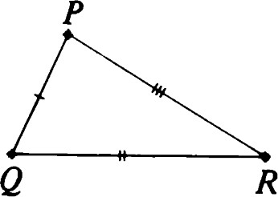

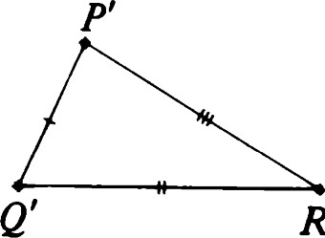R' Figure 2.20 The SSS theorem.

65

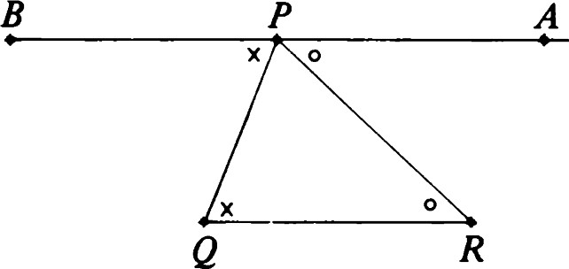

Figure 2.21 Theorem 42. The angle sum of a triangle is T.

d(P, = d(P, + d(Q, - 2d(P, R) cos O, (2.16) where 0 is the radian measure of 4PQR.

Proof: Apply the polarization identity (Exercise 1.29) with x = P — Q and y = R — Q, so that x — y = P — R. Also, recall that

cos 0 = ' (2.17)

IP - QIIR - QI from (2.11).

Theorem 41. Let APQR and AP'Q'R' be such that d(P, Q) = d(P', Q'), d(Q, R) = d(Q', R'), and 4 PQR = 4 P'Q'R' (in radian measure). Then there is an isometry T such that TP = P', TQ = Q', and TR = R'.

Proof: Apply the Law of Cosines to both triangles. The given conditions say that the right sides of (2.16) are equal. Hence, d(P, R) = d(P' , R'), and the SSS theorem may be applied.

Corollary. The base angles of an isosceles triangle are congruent.

Proof: Apply the SAS theorem to APQR and ARQP, where d(P, Q) — d(Q, R).

### Angle sums for triangles

The major result of this section is the following:

Theorem 42. The sum of the radian measures of the three angles in any triangle is equal to ff.

Proof: Let PQR be a triangle. Then the unique line through P parallel to QR is the union of the rays PA and PB, where A = P + R — Q and B = P + Q — R. Note that Q is in the interior of 4BPR because Q = B + R — P. By Theorem 34 the radian measure of 4BPR is equal to the sum of the radian measures of 4BPQ and 4RPQ, whereas 4BPR and 4APR are supplementary. Finally, we apply Theorems 38 and 39 to the alternate angle pairs 4BPQ 4 PQR and 4APR PRQ to complete the proof. These constructions are illustrated in Figure 2.21.

Corollary. If two angles of a triangle are respectively congruent to two angles of another triangle, then the remaining angles are also congruent.

Remark: When we study non-Euclidean plane geometry, we will discover Angle sums for triangles that Theorem 42 is one of the few results that is false in non-Euclidean planes. In fact, from an axiomatic approach, this criterion can be used to distinguish Euclidean from non-Euclidean planes.

EXERCISES

1. Find the fixed points and fixed lines of the indicated affine transformations.

[

1 21] ,[- 1]1 •

2

|  |  |  |
| --- | --- | --- |
| 1  [ | 1] ,  2 |  |
| iii.  [ 1 | 1] ,  2 | [ 21] • |

1. Prove Theorem 4.
2. Let T be a glide reflection with axis m. Show that a line e satisfies Telle if and only if or C -L m.
3. Let e be a line of E2 . Let G be the set of isometries T of E2 satisfying TC = e. Describe the elements of G explicitly and give the group multiplication table.
4. i. Given two intersecting lines, prove that there is a rotation that takes one to the other. Is it unique? ii. Given two parallel lines, prove that there is a translation that takes one to the other. Is it unique?
5. Verify that the mapping described following Theorem 5, which associates to each affine transformation a 3 by 3 matrix, is an injective homomorphism of AF(2) into GL(3).
6. Prove Theorem 7(ii) by a direct computation using linear algebra.
7. Verify formula (2.4), which shows that every ordinary reflection is an affine reflection.
8. Verify the statements in the remark following Theorem 13.
9. If every nonzero vector in R2 is an eigenvector of a 2 by 2 matrix A, show that A is a multiple of the identity matrix.
10. Prove Theorem 18.
11. Complete the proof of Theorem 19.
12. Work out the multiplication table for the group of transformations of Theorem 20 and its subgroups.
13. Verify the remark following the definition of radian measure. 67
14. Prove Theorem 22.
15. Let P = (l, 2), Q = (0, 0), and R = (2, 1). Show that the radian measure of 4 PQR is cos -l (4/5).
16. Find the bisectors of a straight angle in terms of its vertex and the unit direction vectors of its arms.
17. What is the bisector of a zero angle?
18. If QX is a bisector of ar angle 4PQR, prove that OQX and 4 RQX have the same radian measure, namely, half the measure of 4PQR.
19. Prove that the ray QX of Exercise 19 is the only ray having the property described there, unless 4 PQR is a straight angle.
20. Prove that a rotation about P that leaves a ray with origin P fixed must be the identity.
21. Compute the centroid of the following set of points: {(1, 4), (2, 4),



1. Prove Theorem 28. Fill in the details omitted in the text.
2. Prove that there is a reflection interchanging any two lines. Is it unique?
3. Prove that barycentric coordinates are well-defined.
4. With respect to the triangle of reference P = (—1, O), Q = (1, O), R = (0, 1), find the barycentric coordinates of the points: (O, O),



1. Let a, b, and c be three numbers, not all zero. Show that the set of all points whose barycentric coordinates satisfy ax + bp + cv = 0 is a line.
2. Let P be a point and N a unit vector. Show that {XI(X — P, N)  O} is a half-plane.
3. Prove Theorem 32.
4. Prove that every point in the interior of an angle lies on a segment joining points of the arms of the angle.
5. Prove that every point in the interior of a triangle lies on a segment joining points on two sides of the triangle.
6. If PQ and P'Q' are collinear segments of equal length, prove that either or takes PQ to P'Q'.
7. Let P, Q, R, and R' be four distinct points such that d(P, R) d(P, R') and d(Q, R) = d(Q, R'). Prove that R' = OCR, where e = PQ.
8. Let T be an affine transformation and e a line. Prove that the points M = + TP) (as P ranges through C) are all distinct and collinear, or that they all coincide. Express the locus of M (i.e., the line or

point) in terms of the data determining T and e. This result is called Hjelmslev's theorem, although most treatments assume that T is an isometry.

1. If [Cc, PI -+ QI] = [G; P2 -9 Q21, what relationships must hold among the points in question?
2. Show that Theorem 27 and its corollary hold true for affine transformations and affine symmetries.
3. Suppose that an affine transformation has three concurrent fixed lines. Prove that it is a central dilatation or the identity.
4. Extending the notation of Theorem 13, let

Sk,v = Tvsx, for e R and v R2

* 1. Verify the identity

 SX+P,W' where w = sx,uv. Thus show that the set of all sx,v is a group. ii. Show that sx,v is a shear with horizontal axis if and only if = [ E ll.

iii. Show that every shear with horizontal axis may be written in the form sx,v• iv. Show that {sx,vl v, €2) = O} is a group (the case = O is included here).

Remark: The group defined in Exercise 38(i) is called the Galilean group GAL(2). It arises in classical kinematics when describing uniform motion in a straight line. The subset of affine geometry consisting of those facts of Euclidean geometry that continue to make sense when the figure in question is subjected to transformations by the Galilean group is called Galilean geometry and is the subject of an interesting book by I. M. Yaglom [341.

1. Let and be parallel segments. Find a central dilatation taking to 
   1. by a geometric construction, ii. in terms of the end points of the given segments. Can there be more than one such dilatation?
2. Prove that any affine transformation that preserves perpendicularity must be a similarity.
3. Prove Pasch's theorem: If a line intersects one side of a triangle, it must also intersect one of the other sides.
4. Let PQR be a triangle. Let F be the foot of the perpendicular from P

Angle sums for triangles

69

to QR. Prove that F is between Q and R if and only if &PQR and 4 PRQ are acute angles.

1. Let P and Q be distinct points. Show that PQ n QP = PQ.
2. Let T be an affine transformation taking APQR to AP'Q'R' as in Theorem 36. Prove the following facts:
   1. For any X e E2 the barycentric coordinates of TX with reference to AP'Q'R' are the same as those of X with reference to APQR. ii. If

P' = allP + a21Q + a31R, Q' = + a22Q + a32R ,

R' = a13P + a23Q + a33R,

then the barycentric coordinates of X' = TX (with reference to APQR) are related to those of X by the equation

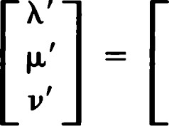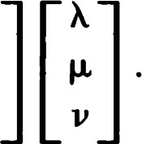a ll a n a 13 am a22 a23 a31 a32 a33

1. Prove Heron's theorem: Let e be a line, and let A and B be points not on e. Among all points X on C, the quantity d(A, X) + d(X, B) is minimum when X is on the segment AB or X is on the segment AB' where B' = oeB.